Output for addition:

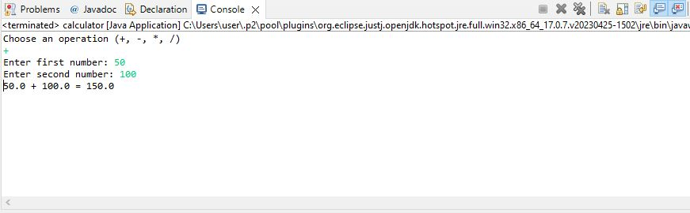

Output for subtraction:

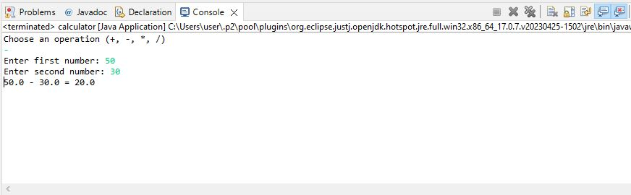

Output for multiplication:

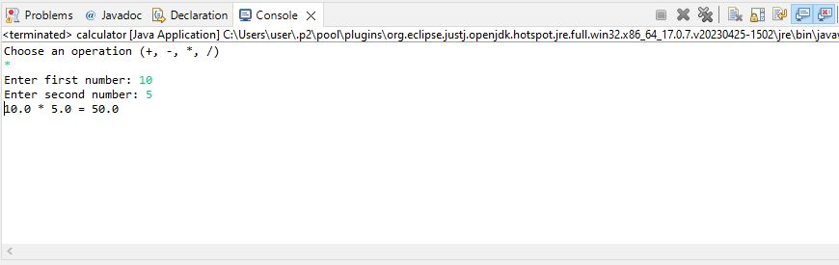

Output for division: 